**DATA SCIENCE – BWT**

**SAIFULLAH KHAN**

**Mini Project Using Data Structure In Python**

**( Task Manager )**

**Introduction**

The Task Manager project is a simple command-line interface (CLI) application developed in Python. It allows users to manage tasks by adding, viewing, updating, and deleting them. The project demonstrates the use of Python classes, lists (a built-in data structure), and basic input/output operations.

**Project Overview:**

The Task Manager project is composed of two main files:

1. **`task_manager.py`:** Contains the `TaskManager` class, which handles the core functionality of task management.
2. **`main.py**`: Contains the CLI logic, which interacts with the user and calls the appropriate methods from the `TaskManager` class.

**Objectives:**

The primary objectives of the Task Manager project are to:

* Provide a simple and intuitive interface for managing tasks.
* Demonstrate the use of object-oriented programming (OOP) principles in Python, such as classes and encapsulation.
* Use a list to store tasks and demonstrate basic list operations.

**Features:**

* **Add Task:** Allows users to add a new task with a title and description.
* **View Tasks:** Displays a list of all tasks with their details.
* **Update Task:** Allows users to update the title, description, and status of an existing task.
* **Delete Task:** Allows users to delete a task by its ID.
* **Exit:** Exits the application.

**Conclusion**

The Task Manager project provides a practical example of using Python for simple task management. It demonstrates key programming concepts such as OOP, list operations, and user interaction through a CLI. This project can be further expanded by adding features such as saving tasks to a file or database, adding user authentication, or creating a graphical user interface (GUI).

**Project Output:**

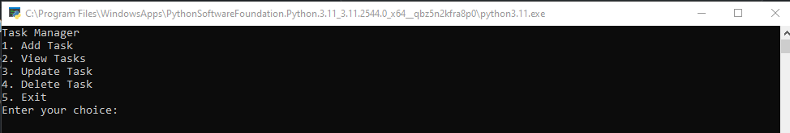

**Add Task:**

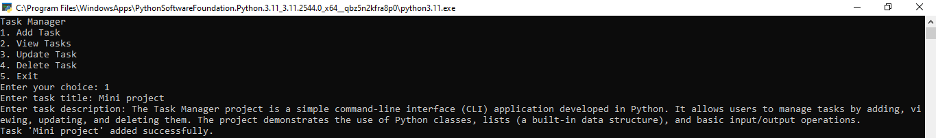

**View Task:**

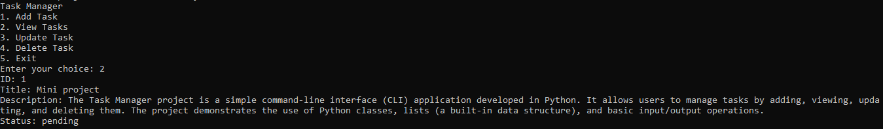

**Update Task:**

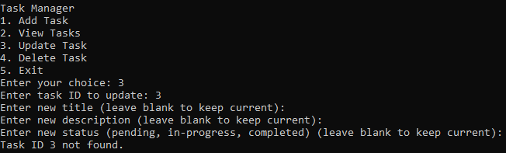

**Delete Task:**

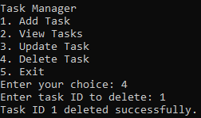

**Exit:**

